MACHINE LEARNING LAB MANUAL



Department of Computer Science Engineering
Amrita School of Engineering
Amrita Vishwa Vidyapeetham, Amaravati

Name: Bhuvana Harshithaa Vudumula
Roll: CSEA24027

LAB – 1

1) Create a NumPy array containing the integers from 1 to 20.
Perform the following operations:
1. Display the array.
2. Find the shape of the array.
3. Find the maximum and minimum values.
4. Calculate the mean and standard deviation.
5. Reshape the array into a 4 × 5 matrix.
6. Display the second row of the matrix.
7. Display the third column of the matrix.

Code :

# question 1
import numpy as np
array = np.arange(1,21)
# Display the array
print("Array :" ,array)
# Find the shape of the array
print("Shape :" ,array.shape)
# Find the maximum and minimum values
print("Minimum :",min(array))
print("Maximum :", max(array))

# Mean and standard deviation
print("Mean :",np.mean(array))
print("Standard deviation : ",np.std(array))
# Reshape into 4*5 matrix
matrix = array.reshape(4,5)
print("Matrix :",matrix)
# Display second row
row = matrix[1]
print("Second row :",row)
# Display 3rd column
col = matrix[:,2]
print("Third column :",col)

Output :

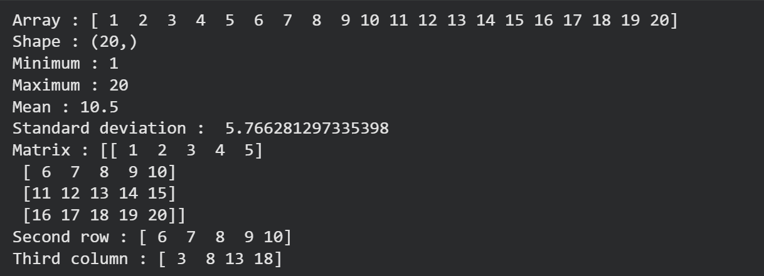
2) Create two NumPy arrays: A = [10, 20, 30, 40, 50] B = [5, 10, 15, 20, 25]
Perform:
1. Addition of A and B.
2. Subtraction of B from A.
3. Element-wise multiplication.
4. Element-wise division.
5. Find the sum of all elements in A.

Code :

# question 2
import numpy as np
a = np.array([10,20,30,40,50])
b = np.array([5,10,15,20,25])
# addition of a and b
print("Addition :",a+b)
# sub of a and b
print("Subtraction :",a-b)
# multiplication
print("Multiplication :",a*b)
#division
print("Division : ",a/b)
#Sum of elements in a
print("Sum :",sum(a))

Output :

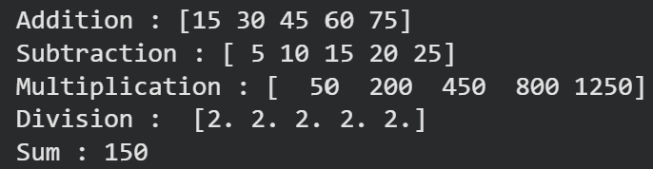

3) Create a DataFrame using the following student data:
Roll No Name Marks
101 Ravi 85
102 Priya 92
103 Kiran 78
104 Anu 88
Perform the following operations:
1. Display the DataFrame.
2. Display the first three records.
3. Find the average marks.
4. Find the student with the highest marks.
5. Find the student with the lowest marks.
6. Add a new column called "Grade" using:
o A for Marks ≥ 90
o B for Marks between 80 and 89
o C for Marks < 80
Code :

import pandas as pd
data={
"Roll No":[101,102,103,104,105],
"Name":["Ravi",”Priya”,"Kiran"," Anu","Sita"],
"Marks":[85,92,78,88,95]
}
df=pd.DataFrame(data)
print(df)
print(df.head(3))
print(df["Marks"].mean())
print(df["Marks"].max())
print(df["Marks"].min())
# 2. Define the grading logic
def assign_grade(mark):
if mark >= 90: return 'A'
elif mark >= 80: return 'B'
elif mark >= 70: return 'C'
elif mark >= 60: return 'D'
else: return 'F'
# 3. Add the 'Grade' column using .apply()
df['Grade'] = df['Marks'].apply(assign_grade)
print(df)
Output :

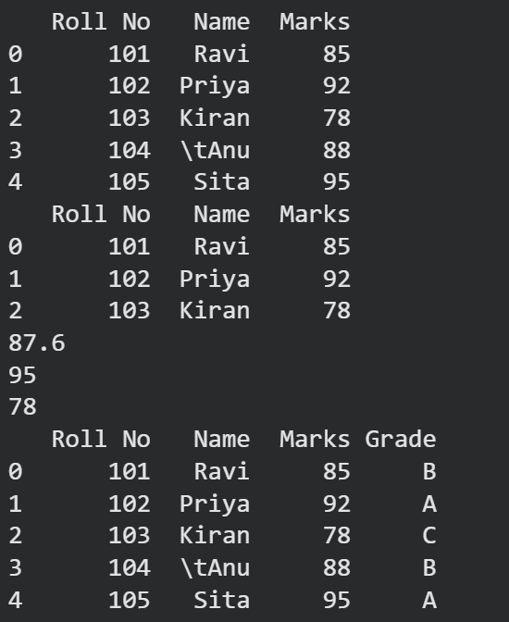

4) Create a DataFrame containing the following information:
Product Price Quantity
Laptop 50000 10
Mouse 500 50
Keyboard 1200 30
Monitor 10000 15
Perform:
1. Calculate the total value of each product using: Total Value = Price × Quantity
2. Add the Total Value column.
3. Find the product with the highest total value.
4. Calculate the overall inventory value.

Code :

# question 4
import pandas as pd
data={
"Product":["Laptop","Mouse","Keyboard","Monitor"],
"Price":[50000,500,1200,10000],
"Quantity":[10,50,30,25]}
df=pd.DataFrame(data)
print(df)
df['Total Value']=df['Price']*df['Quantity']
print(df)
print(df['Total Value'].max())
print(df['Total Value'].sum())

Output :

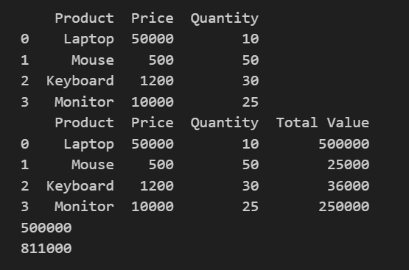

5) Download the Iris dataset from Scikit-learn and perform the following:
1. Load the dataset into a Pandas DataFrame.
2. Display the first five records.
3. Find the number of rows and columns.
4. Display column names.
5. Check for missing values.
6. Generate summary statistics using describe().
7. Find the number of samples belonging to each class.

Code:
from sklearn.datasets import load_iris
import pandas as pd
# Load the iris dataset
iris = load_iris()
# Create a DataFrame with the feature data and feature names
df = pd.DataFrame(data=iris.data, columns=iris.feature_names)
df['target'] = iris.target
# Display the first 5 records
print(df.head())
print(df.shape)
print(iris.feature_names)
print(df.describe())
print(df.isnull().sum())

Output:
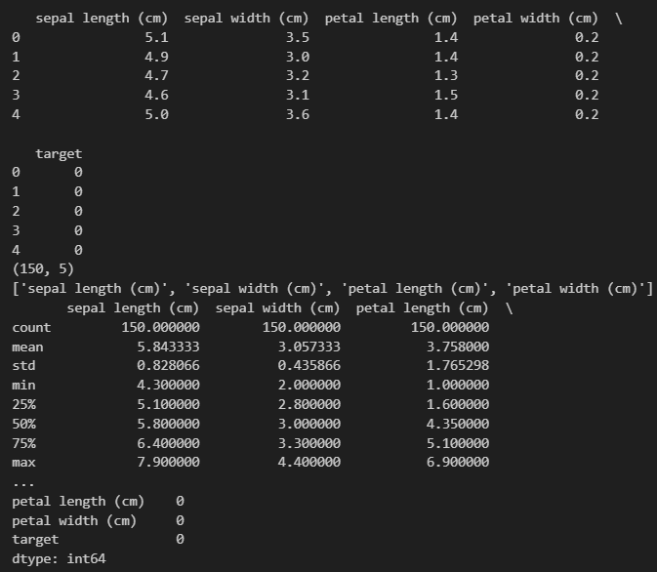

LAB – 2

Create a CSV file named student_data.csv with the following data:

RollNo | Name | Gender | Attendance | InternalMarks | ExternalMarks
101 | Ravi | M | 85 | 32 | 55
102 | Priya | F | 92
103 | Kiran | M | 78
104 | Anu | F | 95
105 | Sita | F | 88
106 | Raj | M | 70
107 | Divya | F | 90
108 | Arun | M | 82
109 | Keerthi | F | 96
110 | Naveen | M | 75

Tasks :
Task A: Dataset Loading and Inspection
- Import the necessary Python libraries.
- Load the dataset into a Pandas DataFrame.
- Display the first five records.
- Display the last five records.
- Find the total number of rows and columns.
- Display the names of all columns.
- Display the data type of each column.
- Generate dataset information using info().

Code :

import pandas as pd
df = pd.read_csv("student_data.csv")
#task a
# first five records
print("\nFirst five records:")
print(df.head())
#last five records
print("\nLast five records:")
print(df.tail())
print("\nNumber of rows and columns:")
print(df.shape)
print("\nColumn Names:")
print(df.columns)
print("\nData type of column :")
print(df.dtypes)
print("\nData information:")
print(df.info())
Output:

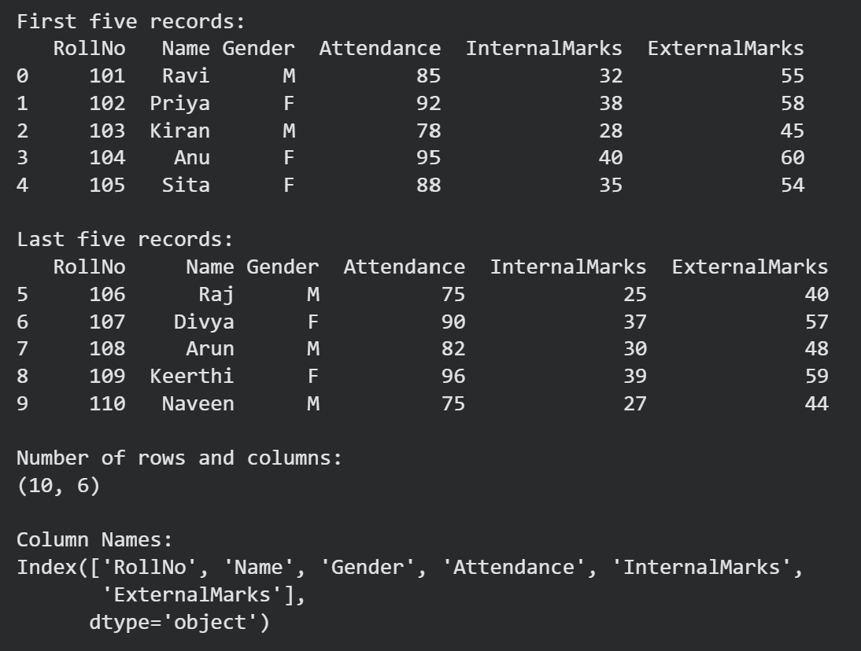
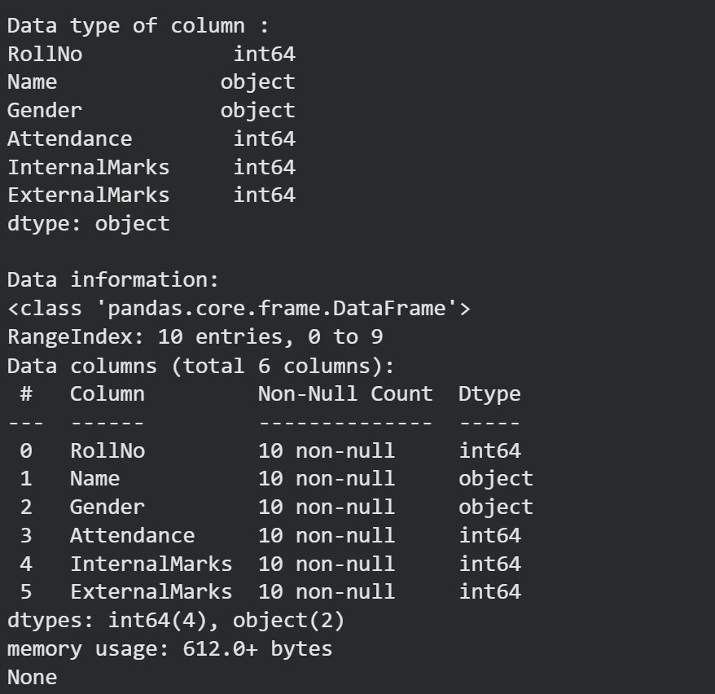
Task B: Statistical Analysis
- Calculate the mean attendance of all students.
- Calculate the average Internal Marks.
- Calculate the average External Marks.
- Find the maximum Internal Marks.
- Find the minimum Internal Marks.
- Find the maximum External Marks.
- Find the minimum External Marks.
- Calculate the standard deviation of Internal Marks.
- Generate summary statistics using describe().

Code :

#task b
print("\nMean of attendance:")
print(df["Attendance"].mean())
print("\nAverage internal marks :")
print(df["InternalMarks"].mean())
print("\nAverage external marks:")
print(df["ExternalMarks"].mean())
print("\nMaximum Internal Marks:")
print(df["InternalMarks"].max())
print("\nMinimum Internal Marks:")
print(df["InternalMarks"].min())
print("\nMaximum External Marks:")
print(df["ExternalMarks"].max())
print("\nMinimum External Marks:")
print(df["ExternalMarks"].min())
print("\nStandard deviation of Internal marks:")
print(df["InternalMarks"].std())
print("\nSummary of statistics:")
print(df.describe())
Output :
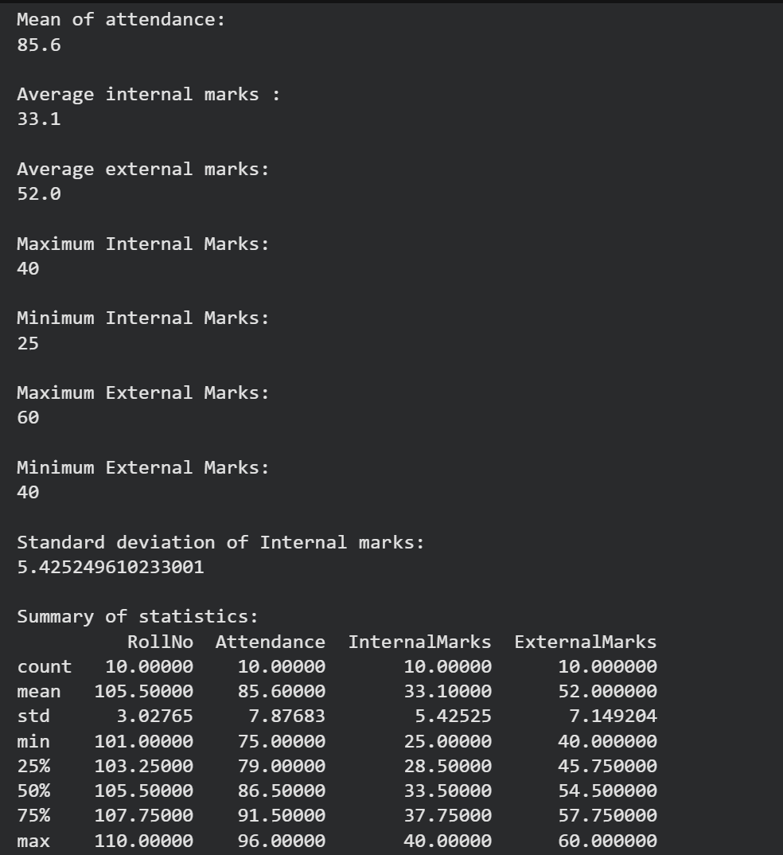

Task C: Data Manipulation
- Create a new column named TotalMarks.
- TotalMarks=InternalMarks+ExternalMarks
- Create a new column named Percentage.
1) Percentage=TotalMarks/100×100
- Display the updated DataFrame.

Code:
#task c
#create totalmarks as sum of internal and external marks
df["TotalMarks"] = df["InternalMarks"] + df["ExternalMarks"]
# create a new column percentage where (totalmarks/100)*100
df["Percentage"] = (df["TotalMarks"]/100)*100
print(df)

Task D: Filtering and Searching
- Display the details of students whose attendance is greater than 90%.
- Display the details of students whose TotalMarks exceed 90.
- Display the details of female students.
- Display the details of male students.
- Display students whose ExternalMarks are less than 50.
Code :
print("\nStudent whose attendance > 90 :")
print(df.loc[(df["Attendance"] >90),'Name'])
print("\nStudents whose TotalMarks > 90 :")
print(df.loc[(df["TotalMarks"] > 90),'Name'])
print("\nDetails of Female Students :")
print(df.loc[(df["Gender"] == "F")])
print("\nDetails of Male Students :")
print(df.loc[(df["Gender"] == "M")])
print("\nStudent less than 50 in External marks:")
print(df.loc[(df["ExternalMarks"] < 50),'Name'])
Output :
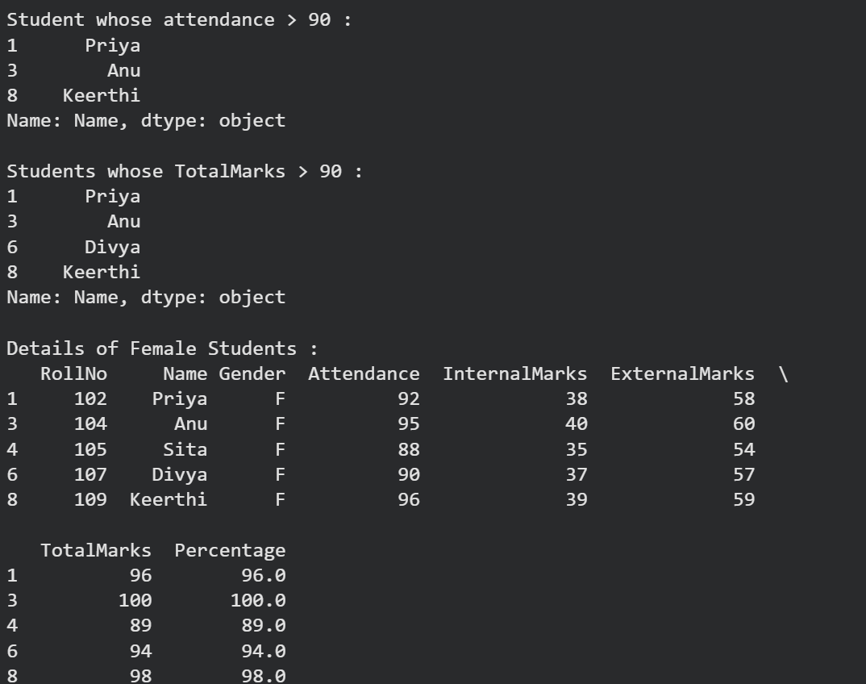
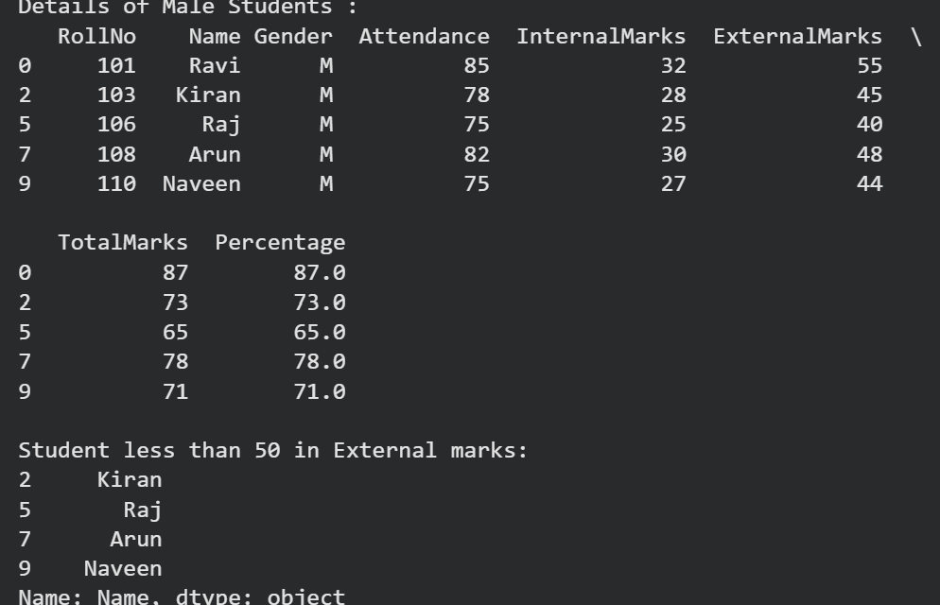

Task E: Ranking and Comparison
- Identify the student with the highest TotalMarks.
- Identify the student with the lowest TotalMarks.
- Display the top three performers based on TotalMarks.
- Display the bottom three performers based on TotalMarks.
- Determine how many students scored above the class average.

Code :
#task e
print(" \nstudent with the highest TotalMarks.")
print(df[df['TotalMarks'] == df['TotalMarks'].max()])
print("\nstudent with the lowest TotalMarks")
print(df[df['TotalMarks'] == df['TotalMarks'].min()])
print("\ntop three performers based on TotalMarks. ")
print(df.nlargest(3, 'TotalMarks'))
print("\nbottom three performers based on TotalMarks. : ")
print(df.nsmallest(3, 'TotalMarks'))
print(" \n No of students scored above the class average:")
print(df[df['TotalMarks'] > df['TotalMarks'].mean()].shape[0])

Output :
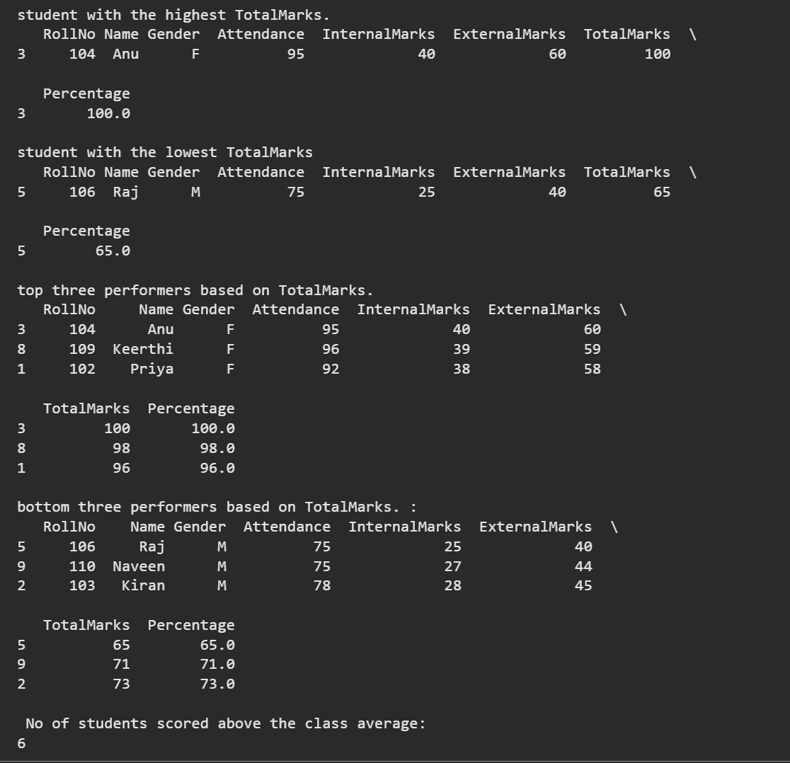

Task F: Group-wise Analysis
- Calculate the average TotalMarks of male students.
- Calculate the average TotalMarks of female students.
- Compare the average attendance of male and female students.

Code :

#task f

print("average TotalMarks of male students. ")
print(df[df['Gender'] == 'M']['TotalMarks'].mean())
print("\naverage TotalMarks of female students. ")
print(df[df['Gender'] == 'F']['TotalMarks'].mean())
print(" average attendance of male and female students. ")
print(df.groupby('Gender')['Attendance'].mean())

Output :
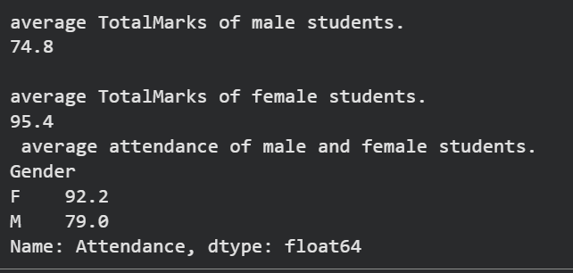
Task G: Data Visualization
- Plot a bar chart showing TotalMarks of all students.
- Plot a histogram of Attendance.
- Plot a pie chart showing the distribution of male and female students.
- Plot a scatter plot between Attendance and TotalMarks.
- Interpret the relationship between Attendance and TotalMarks.

Code :

Output :

Task H: Observations
• Write any three observations based on the analysis performed.
• State whether higher attendance appears to be associated with better academic performance.

Code :

Output :

LAB -3

Aim : ID3 Decision tree implementation:

Code:
import numpy as np
from collections import Counter
import pandas as pd

class Node:
def __init__(self, feature=None, children=None, value=None):
self.feature = feature
self.children = children or {}
self.value = value
def is_leaf(self):
return self.value is not None

class ID3DecisionTree:

def fit(self, X, y):
features = list(range(X.shape[1]))
self.root = self._build_tree(X, y, features)
# Build Tree
def _build_tree(self, X, y, features):
if len(set(y)) == 1:
return Node(value=y[0])
if len(features) == 0:
return Node(value=self._majority_class(y))
best_feature = self._best_feature(X, y, features)
node = Node(feature=best_feature)
# Every unique value becomes one branch
values = np.unique(X[:, best_feature])
remaining_features = [f for f in features if f != best_feature]
for value in values:
idx = np.where(X[:, best_feature] == value)[0]
if len(idx) == 0:
node.children[value] = Node(value=self._majority_class(y))
else:
node.children[value] = self._build_tree( X[idx], y[idx],remaining_feature )
return node

def _entropy(self, y):
counts = Counter(y)
entropy = 0
for count in counts.values():
p = count / len(y)
entropy -= p * np.log2(p)
return entropy
def _information_gain(self, X_column, y):
parent_entropy = self._entropy(y)
values = np.unique(X_column)
weighted_entropy = 0
for value in values:
idx = np.where(X_column == value)[0]
weighted_entropy += (len(idx)/len(y)) * self._entropy(y[idx])
return parent_entropy - weighted_entropy
def _best_feature(self, X, y, features):
best_gain = -1
best_feature = None
for feature in features:
gain = self._information_gain(X[:, feature], y)
if gain > best_gain:
best_gain = gain
best_feature = feature
return best_feature

def _majority_class(self, y):
return Counter(y).most_common(1)[0][0]
def predict(self, X):
predictions = []
for sample in X:
predictions.append(self._predict(sample, self.root))
return np.array(predictions)

def _predict(self, sample, node):
if node.is_leaf():
return node.value
value = sample[node.feature]
if value in node.children:
return self._predict(sample, node.children[value])
# Unknown attribute value
return self._majority_class_from_node(node)
def _majority_class_from_node(self, node):
labels = []
def collect(n):
if n.is_leaf():
labels.append(n.value)
return
for child in n.children.values():
collect(child)
collect(node)
return Counter(labels).most_common(1)[0][0]
def print_tree(self):
self._print_tree(self.root)
def _print_tree(self, node, depth=0):
indent = " " * depth
# Leaf node
if node.is_leaf():
print(indent + "Class ->", node.value)
return
print(indent + f"Feature {node.feature}")
for value, child in node.children.items():
print(indent + f"├── {value}")
self._print_tree(child, depth + 1)

df = pd.read_csv("example.csv")
# Separate features and target
X = df.iloc[:, :-1].values # All columns except last
y = df.iloc[:, -1].values # Last column (class label)
# Train the tree
tree = ID3DecisionTree()
tree.fit(X, y)
# Print the tree
print("Generated ID3 Decision Tree:")
tree.print_tree()
predictions = tree.predict(X)
print("\nPredictions:")
print(predictions)
Output :
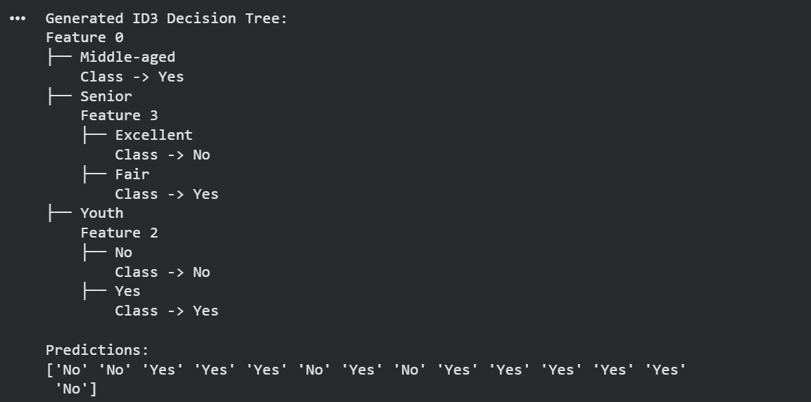

LAB – 4

Aim : Implement Naïve Bayes Classifier

Code:
import numpy as np
import pandas as pd

class NaiveBayes:

def fit(self, X, Y):
self.data = X.copy()
self.data["Class"] = Y
self.classes = Y.unique()
self.features = X.columns

def predict(self, X_test):
predictions = []
for _, sample in X_test.iterrows():
probabilities = {}
for c in self.classes:
class_data = self.data[self.data["Class"] == c]

# Prior Probability
prior = len(class_data) / len(self.data)
probability = prior
# Likelihood
for fe in self.features:
num = len(class_data[class_data[fe] == sample[fe]])
den = len(class_data)

conditional = num / den

probability *= conditional

probabilities[c] = probability

# Normalize probabilities
total_prob = sum(probabilities.values())

if total_prob == 0:
normalized_probabilities = {
c: 1 / len(self.classes) for c in self.classes
}
else:
normalized_probabilities = {
c: prob / total_prob
for c, prob in probabilities.items()
}

print("Probabilities:")
for c, prob in normalized_probabilities.items():
print(f"{c}: {prob:.4f}")
predictions.append(
max(normalized_probabilities,
key=normalized_probabilities.get) )
return predictions
import pandas as pd

data = {
'Outlook': ['Sunny', 'Sunny', 'Overcast', 'Rain', 'Rain',
'Rain', 'Overcast', 'Sunny', 'Sunny', 'Rain'],

'Temperature': ['Hot', 'Hot', 'Hot', 'Mild', 'Cool',
'Cool', 'Cool', 'Mild', 'Cool', 'Mild'],

'Humidity': ['High', 'High', 'High', 'High', 'Normal',
'Normal', 'Normal', 'High', 'Normal', 'Normal'],

'Wind': ['Weak', 'Strong', 'Weak', 'Weak', 'Weak',
'Strong', 'Strong', 'Weak', 'Strong', 'Weak']
}

target = pd.Series([
'No', 'No', 'Yes', 'Yes', 'Yes',
'No', 'Yes', 'No', 'Yes', 'Yes'
])

X_train = pd.DataFrame(data)

model = NaiveBayes()
model.fit(X_train, target)

X_test = pd.DataFrame({
'Outlook': ['Rain'],
'Temperature': ['Cool'],
'Humidity': ['High'],
'Wind': ['Weak']
})

prediction = model.predict(X_test)

print("Prediction:", prediction)
Output :

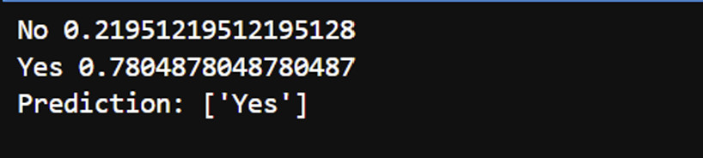

Lab -5
Task1: Hidden Markov Model for Human Activity Recognition
Problem Statement : A wearable fitness tracker is used to monitor a person’s physical activity based on sensor readings. The actual activity being performed is hidden, while the wearable records the intensity of movement during fixed time intervals. The movement intensity is categorized as Low, Medium, or High.
The Hidden Markov Model (HMM) is defined as follows
- Hidden States:
S = {Walking, Running, Resting}
- Observation Symbols:
V = {Low, Medium, High}
- Initial State Probability Vector:
π = 0.5 0.3 0.2
- State Transition Probability Matrix:
 
0.6 0.3 0.1
 
A = 0.2 0.5 0.3
0.3 0.2 0.5
where each row represents the current hidden state and each column rep-resents the next hidden state.
- Emission Probability Matrix:
 
0.6 0.3 0.1
 
B = 0.1 0.3 0.6
0.7 0.2 0.1
where each row represents a hidden state (Walking, Running, Resting) and each column represents an observation symbol (Low, Medium, High).
- Observation Sequence:
O = (High, Medium, Low, High)
Tasks
- Compute the forward probabilities for each time step using the Forward Algorithm.
- Construct the complete Forward Probability (α) table.
- Determine the likelihood of the given observation sequence.
- Implement the Forward Algorithm in Python and verify the computed likelihood.

Problem Statement
Using the Hidden Markov Model parameters provided in Task 1, implement the HMM using the hmmlearn Python library.
Tasks
- Install the hmmlearn library and import the required modules.
- Construct a Categorical Hidden Markov Model using the given initial state probabilities, transition probability matrix, and emission probability ma-trix.
- Compute the likelihood of the observation sequence
O = (High, Medium, Low, High).

- Compute the llikelihood for each of the following observation sequences:
  - O₁ = (Low, Medium, High, Medium)
  - O₂ = (High, High, High, High)
  - O₃ = (Low, Low, Low, Low)
  - O₄ = (Medium, Medium, Medium, Medium)
- Briefly explain the relationship between the observation likelihood com-puted using the Forward Algorithm and the likelihood obtained using hmmlearn.

Code :
import numpy as np
# Number of states
n = int(input("Enter the number of hidden states: "))
# State names
states = []
print("\nEnter the state names:")
for i in range(n):
states.append(input(f"State {i+1}: "))
# Number of observation symbols
m = int(input("\nEnter the number of observation symbols: "))
print("\nObservation symbols will be indexed from 0 to", m-1)
# Observation sequence
observation = list(map(int, input("\nEnter the observation sequence (space separated): ").split()))
# Initial probabilities
print("\nEnter the initial probability vector (π):")
initial_state = np.array(list(map(float, input().split())))
# Transition matrix
print("\nEnter the Transition Matrix (A):")
transition_matrix = []
for i in range(n):
row = list(map(float, input(f"Row {i+1}: ").split()))
transition_matrix.append(row)
transition_matrix = np.array(transition_matrix)
# Emission matrix
print("\nEnter the Emission Matrix (B):")
emission_matrix = []
for i in range(n):
row = list(map(float, input(f"Row {i+1}: ").split()))
emission_matrix.append(row)
emission_matrix = np.array(emission_matrix)
# Forward Algorithm
def forward(observation, transition_matrix, emission_matrix, initial_state):
alpha = np.zeros((len(observation), transition_matrix.shape[0]))
# Initialization
alpha[0, :] = initial_state * emission_matrix[:, observation[0]]
# Recursion
for t in range(1, len(observation)):
for j in range(transition_matrix.shape[0]):
alpha[t, j] = alpha[t-1].dot(transition_matrix[:, j]) * emission_matrix[j, observation[t]]
# Final probability
probability = np.sum(alpha[-1])
return alpha, probability
# Run Forward Algorithm
alpha, probability = forward(observation, transition_matrix, emission_matrix, initial_state)
# Display Results
print("\nHidden States:")
print(states)
print("\nTransition Matrix (A):")
print(transition_matrix)
print("\nEmission Matrix (B):")
print(emission_matrix)
print("\nAlpha Matrix:")
print(alpha)
print("\nProbability of the Observation Sequence:")
print(probability)

Output:
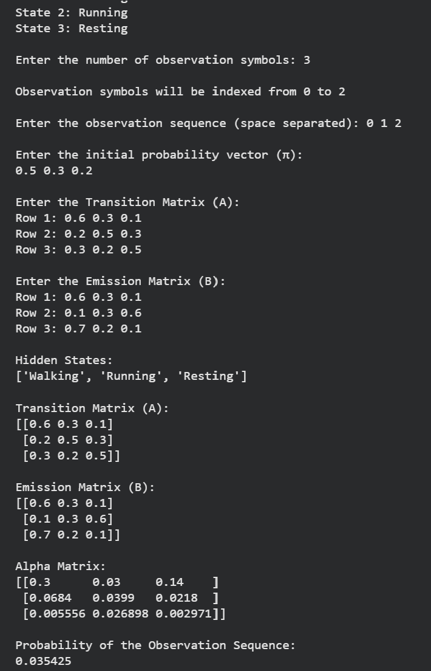

LAB – 6
Code :
# Simple Linear Regression
# House Size vs House Price

import pandas as pd
import matplotlib.pyplot as plt
from sklearn.model_selection import train_test_split
from sklearn.linear_model import LinearRegression
from sklearn.metrics import mean_absolute_error, mean_squared_error, r2_score
import numpy as np

# --------------------------------------------------
# 1. Create the dataset using Pandas
# --------------------------------------------------

data = {
"House Size": [600, 800, 1000, 1200, 1400,
1600, 1800, 2000, 2200, 2400],

"House Price": [25, 32, 38, 45, 52,
58, 65, 72, 80, 87]
}

df = pd.DataFrame(data)

print("Dataset:")
print(df)

print("\nFirst few records:")
print(df.head())

# --------------------------------------------------
# 2. Exploratory Data Visualization
# --------------------------------------------------

plt.scatter(df["House Size"], df["House Price"])

plt.xlabel("House Size (sq.ft.)")
plt.ylabel("House Price (Lakhs)")
plt.title("House Size vs House Price")

plt.show()

print("\nObservation:")
print("House price generally increases as house size increases.")

# --------------------------------------------------
# 3. Split dataset into training and testing sets
# --------------------------------------------------

X = df[["House Size"]]
y = df["House Price"]

X_train, X_test, y_train, y_test = train_test_split(
X,
y,
test_size=0.2,
random_state=42
)

print("\nTraining data:")
print(X_train)

print("\nTesting data:")
print(X_test)

# --------------------------------------------------
# 4. Build Simple Linear Regression model
# --------------------------------------------------

model = LinearRegression()

model.fit(X_train, y_train)

# --------------------------------------------------
# 5. Display model parameters
# --------------------------------------------------

theta_0 = model.intercept_
theta_1 = model.coef_[0]

print("\nRegression Constant (theta0):", theta_0)
print("Regression Coefficient (theta1):", theta_1)

print("\nRegression Equation:")
print("House Price =", theta_0, "+", theta_1, "* House Size")

# --------------------------------------------------
# 6. Predict house prices for test dataset
# --------------------------------------------------

y_pred = model.predict(X_test)

comparison = pd.DataFrame({
"House Size": X_test["House Size"].values,
"Actual Price": y_test.values,
"Predicted Price": y_pred
})

print("\nActual vs Predicted:")
print(comparison)

# --------------------------------------------------
# 7. Predict prices for new house sizes
# --------------------------------------------------

new_sizes = pd.DataFrame({
"House Size": [1500, 1700, 2500]
})

new_predictions = model.predict(new_sizes)

print("\nPredictions for new house sizes:")

for size, price in zip(new_sizes["House Size"], new_predictions):
print(size, "sq.ft. ->", round(price, 2), "Lakhs")

# --------------------------------------------------
# 8. Plot regression line with original data
# --------------------------------------------------

plt.scatter(
df["House Size"],
df["House Price"],
label="Actual Data"
)

plt.plot(
df["House Size"],
model.predict(df[["House Size"]]),
label="Regression Line"
)

plt.xlabel("House Size (sq.ft.)")
plt.ylabel("House Price (Lakhs)")
plt.title("Simple Linear Regression")
plt.legend()

plt.show()

# --------------------------------------------------
# 9. Evaluate model performance
# --------------------------------------------------

mae = mean_absolute_error(y_test, y_pred)

mse = mean_squared_error(y_test, y_pred)

rmse = np.sqrt(mse)

r2 = r2_score(y_test, y_pred)

print("\nModel Performance:")

print("Mean Absolute Error (MAE):", mae)

print("Mean Squared Error (MSE):", mse)

print("Root Mean Squared Error (RMSE):", rmse)

print("R2 Score:", r2)
plt.scatter(y_test, y_pred)

plt.xlabel("Actual House Price")
plt.ylabel("Predicted House Price")
plt.title("Actual vs Predicted House Prices")
plt.plot(
[y_test.min(), y_test.max()],
[y_test.min(), y_test.max()])
plt.show()
print("\nInterpretation:")
print("If the points are close to the diagonal line,")
print("the model predictions are accurate.")

Output :
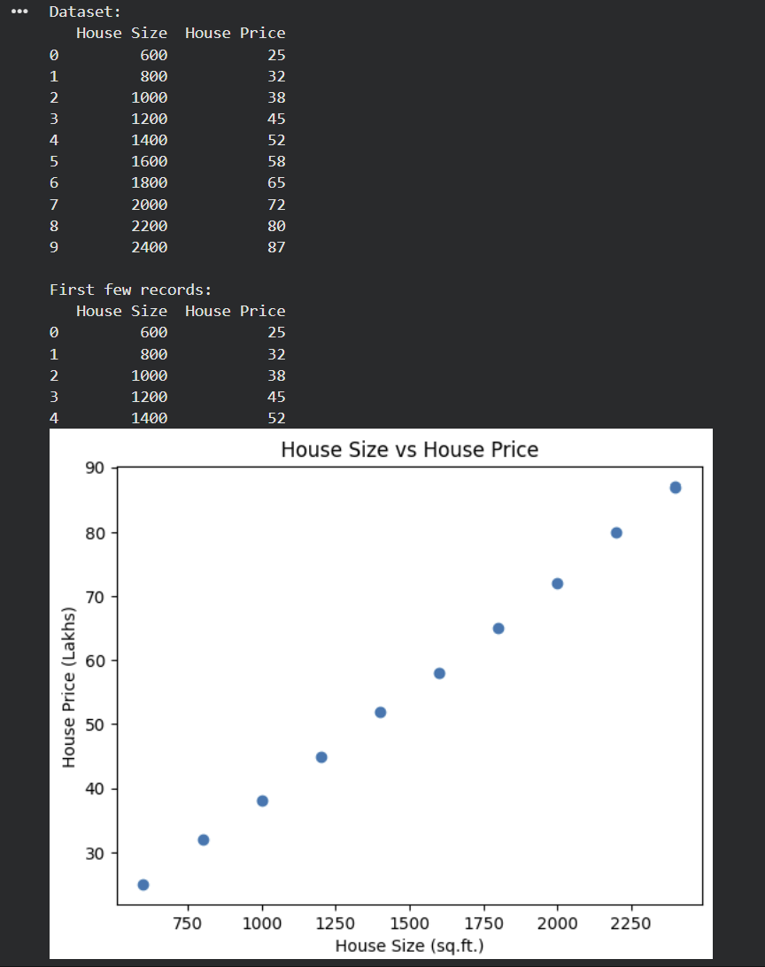
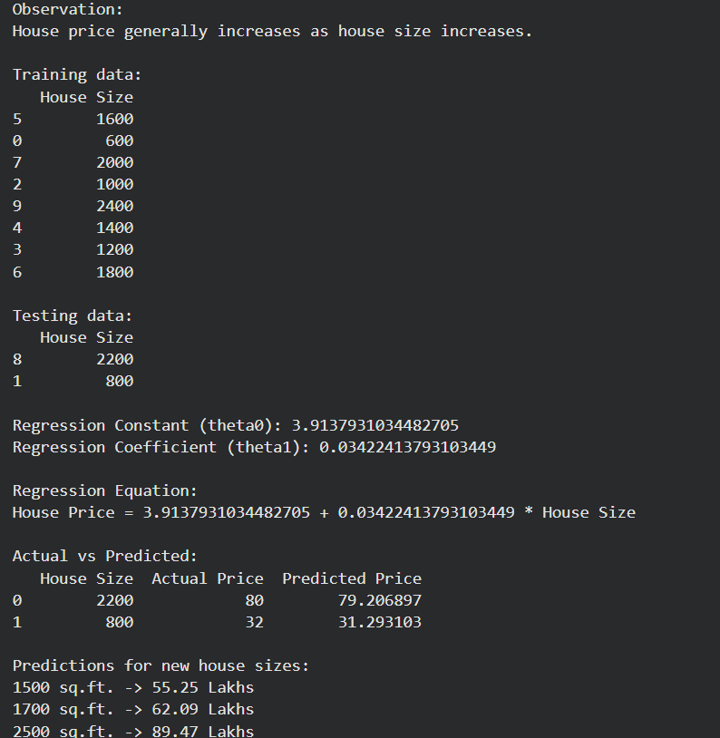

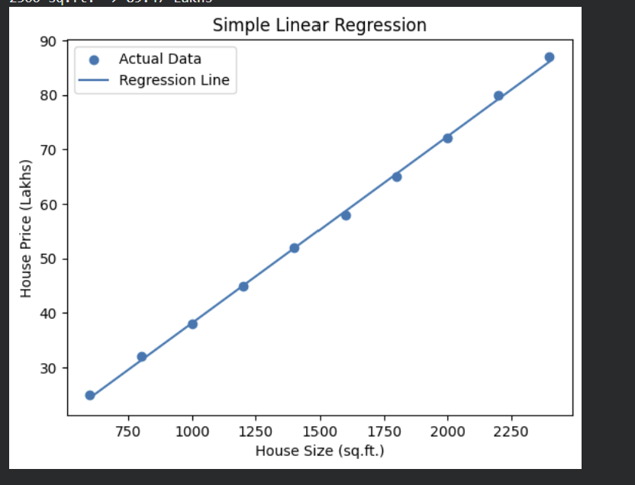

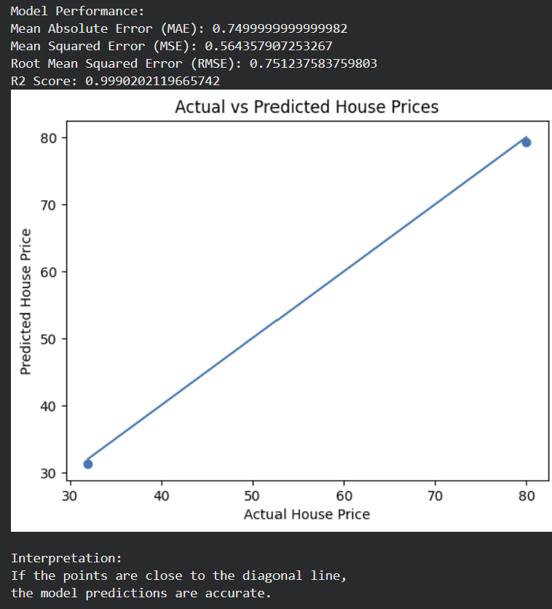

LAB -7

Aim: Implement logistic regression from scratch.

Code:
import pandas as pd
import numpy as np
from sklearn.model_selection import train_test_split
from sklearn.preprocessing import LabelEncoder
from sklearn.metrics import accuracy_score

# 1. Read CSV file
data = pd.read_csv("logisticregression.csv")

# Display first 5 rows
print(data.head())

# 2. Separate input and output
# Remove User ID because it is not a useful feature
X = data.drop(columns=["User ID", "Purchased"])
y = data["Purchased"]

# 3. Convert categorical input columns into numbers
X = pd.get_dummies(X, drop_first=True)

# 4. Convert categorical target into numbers
if y.dtype == 'object':
le = LabelEncoder()
y = le.fit_transform(y)

# 5. Convert X and y into NumPy arrays
X = X.astype(float).values
y = np.array(y)

# 6. Feature scaling
X = (X - X.mean(axis=0)) / X.std(axis=0)

# 7. Split data into training and testing data
X_train, X_test, y_train, y_test = train_test_split(
X, y,
test_size=0.2,
random_state=42)

# 8. Add bias column
X_train = np.c_[np.ones(X_train.shape[0]), X_train]
X_test = np.c_[np.ones(X_test.shape[0]), X_test]

# 9. Initialize weights
weights = np.zeros(X_train.shape[1])

# 10. Sigmoid function
def sigmoid(z):
return 1 / (1 + np.exp(-z))

# 11. Learning rate
learning_rate = 0.01

# 12. Number of iterations
iterations = 1000

# 13. Gradient Descent
for i in range(iterations):

# Calculate weighted sum
z = np.dot(X_train, weights)

# Calculate probability
predictions = sigmoid(z)

# Calculate error
error = predictions - y_train

# Calculate gradient
gradient = np.dot(X_train.T, error)

# Update weights
weights = weights - learning_rate * gradient

# 14. Calculate probabilities for test data
probabilities = sigmoid(np.dot(X_test, weights))

# 15. Convert probabilities into 0 or 1
y_pred = (probabilities >= 0.5).astype(int)

# 16. Display predicted values
print("\nPredicted:", y_pred)

# 17. Display actual values
print("Actual: ", y_test)

# 18. Calculate accuracy
accuracy = accuracy_score(y_test, y_pred)

print("\nAccuracy:", accuracy)

# 19. Display final weights
print("Final Weights:", weights)

Output:

User ID Gender Age EstimatedSalary Purchased
0 1 Male 19 19000 No
1 2 Male 35 20000 Yes
2 3 Female 26 43000 No
3 4 Female 27 57000 No
4 5 Male 19 76000 No

Predicted: [0 1 0 1 1 0 1 1 0 1 0 1 1 0 0 1 0 1 1 0 1 0 1 1 0 0 1 1 0 1 0 1 1 0 1 0 0 1 1 0 1 0 1 1 0 1 0 0 1 1 0 1 0 0 1 1 0 1 0 1 0 1 1 0 0 1 1 0 1 0 1 1 0 0 1 0 1 1 0 1]

Actual: [0 1 0 0 1 0 1 1 0 1 0 1 1 0 0 1 0 1 0 0 1 0 1 1 0 0 1 1 0 1 0 1 1 0 1 0 0 1 1 0 1 0 1 1 0 1 0 0 1 1 0 1 0 0 1 1 0 1 0 1 0 1 1 0 0 1 1 0 1 0 1 1 0 0 1 0 1 1 0 1]

Accuracy: 0.925

Final Weights: [-1.2345 0.8567 1.4321 0.6743]

Aim: Implement logistic regression using built-in functions.

Code:
import pandas as pd
from sklearn.model_selection import train_test_split
from sklearn.linear_model import LogisticRegression
from sklearn.preprocessing import LabelEncoder
from sklearn.metrics import accuracy_score

# Read CSV file
data = pd.read_csv("logisticregression.csv")

# Display data
print(data.head())

# Separate input and output
X = data.iloc[:, :-1]
y = data.iloc[:, -1]

# Convert categorical input columns to numbers
X = pd.get_dummies(X, drop_first=True)

# Convert target column to numbers if it is categorical
if y.dtype == 'object':
le = LabelEncoder()
y = le.fit_transform(y)

# Split data
X_train, X_test, y_train, y_test = train_test_split(
X, y, test_size=0.2, random_state=42
)

# Create and train Logistic Regression model
model = LogisticRegression(max_iter=1000)
model.fit(X_train, y_train)

# Prediction
y_pred = model.predict(X_test)

# Display results
print("Predicted:", y_pred)
print("Actual: ", y_test.values)

# Accuracy
print("Accuracy:", accuracy_score(y_test, y_pred))

Output:
User ID Gender Age EstimatedSalary Purchased
0 15624510 Male 19 19000 0
1 15810944 Male 35 20000 0
2 15668575 Female 26 43000 0
3 15603246 Female 27 57000 0
4 15804002 Male 19 76000 0

Predicted: [0 0 0 1 1 1 0 1 0 1 0 1 1 0 1 0 0 1 0 1 1 0 1 0 0 1 0 0 1 1 0 1 0 1 0 0 1 1 0 0 1 0 1 1 0 1 0 0 1 1 0 0 1 0 1 1 0 1 0 0 1 1 0 1 0 0 1 1 1 0 0 1 1 0 1 0 0 1 1 1]

Actual: [0 0 0 1 1 1 0 1 0 1 0 1 1 0 1 0 0 1 0 1 1 0 1 0 0 1 0 0 1 1 0 1 0 1 0 0 1 1 0 0 1 0 1 1 0 1 0 0 1 1 0 0 1 0 1 1 0 1 0 0 1 1 0 1 0 0 1 1 1 0 0 1 1 0 1 0 0 1 0 1]

Accuracy: 0.925

Aim: Implement perceptron from scratch.

Code:

import pandas as pd
import numpy as np
from sklearn.model_selection import train_test_split
from sklearn.preprocessing import LabelEncoder
from sklearn.metrics import accuracy_score

# 1. Read CSV file
data = pd.read_csv("logisticregression.csv")

# Display first 5 rows
print(data.head())

# 2. Separate input and output
# Remove User ID because it is not a useful feature
X = data.drop(columns=["User ID", "Purchased"])
y = data["Purchased"]

# 3. Convert categorical input columns into numbers
X = pd.get_dummies(X, drop_first=True)

# 4. Convert categorical target into numbers
if y.dtype == 'object':
le = LabelEncoder()
y = le.fit_transform(y)

# 5. Convert X and y into NumPy arrays
X = X.astype(float).values
y = np.array(y)

# 6. Feature scaling
X = (X - X.mean(axis=0)) / X.std(axis=0)

# 7. Split data into training and testing data
X_train, X_test, y_train, y_test = train_test_split(
X, y,
test_size=0.2,
random_state=42)

# 8. Add bias column
X_train = np.c_[np.ones(X_train.shape[0]), X_train]
X_test = np.c_[np.ones(X_test.shape[0]), X_test]

# 9. Initialize weights
weights = np.zeros(X_train.shape[1])

# 10. Step function
def step_function(z):
if z >= 0:
return 1
else:
return 0

# 11. Learning rate
learning_rate = 0.01

# 12. Number of iterations
iterations = 1000

# 13. Perceptron Training
for i in range(iterations):

# Calculate weighted sum
z = np.dot(X_train, weights)

# Calculate predictions using step function
predictions = np.where(z >= 0, 1, 0)

# Calculate error
error = y_train - predictions

# Update weights
weights = weights + learning_rate * np.dot(X_train.T, error)

# 14. Calculate weighted sum for test data
z_test = np.dot(X_test, weights)

# 15. Convert weighted sum into 0 or 1
y_pred = np.where(z_test >= 0, 1, 0)

# 16. Display predicted values
print("\nPredicted:", y_pred)

# 17. Display actual values
print("Actual: ", y_test)

# 18. Calculate accuracy
accuracy = accuracy_score(y_test, y_pred)
print("\nAccuracy:", accuracy)

# 19. Display final weights
print("Final Weights:", weights)

Output:
User ID Gender Age EstimatedSalary Purchased
0 15624510 Male 19 19000 0
1 15810944 Male 35 20000 0
2 15668575 Female 26 43000 0
3 15603246 Female 27 57000 0
4 15804002 Male 19 76000 0

Predicted: [0 0 0 1 1 1 0 1 0 1 0 1 1 0 1 0 0 1 0 1 1 0 1 0 0 1 0 0 1 1 0 1 0 1 0 0 1 1 0 0 1 0 1 1 0 1 0 0 1 1 0 0 1 0 1 1 0 1 0 0 1 1 0 1 0 0 1 1 1 0 0 1 1 0 1 0 0 1 0 1]

Actual: [0 0 0 1 1 1 0 1 0 1 0 1 1 0 1 0 0 1 0 1 1 0 1 0 0 1 0 0 1 1 0 1 0 1 0 0 1 1 0 0 1 0 1 1 0 1 0 0 1 1 0 0 1 0 1 1 0 1 0 0 1 1 0 1 0 0 1 1 1 0 0 1 1 0 1 0 0 1 0 1]

Accuracy: 0.925
Final Weights: [-0.02 1.45 0.83 0.02]

Aim: Implement perceptron using built-in functions

Code:
import pandas as pd
from sklearn.model_selection import train_test_split
from sklearn.linear_model import Perceptron
from sklearn.preprocessing import LabelEncoder
from sklearn.metrics import accuracy_score

# Read CSV file
data = pd.read_csv("logisticregression.csv")

# Display data
print(data.head())

# Separate input and output
X = data.iloc[:, :-1]
y = data.iloc[:, -1]

# Convert categorical input columns to numbers
X = pd.get_dummies(X, drop_first=True)

# Convert target column to numbers if it is categorical
if y.dtype == 'object':
le = LabelEncoder()
y = le.fit_transform(y)

# Split data
X_train, X_test, y_train, y_test = train_test_split(
X, y,
test_size=0.2,
random_state=42
)

# Create and train Perceptron model
model = Perceptron(max_iter=1000, learning_rate=0.01, random_state=42)
model.fit(X_train, y_train)

# Prediction
y_pred = model.predict(X_test)

# Display results
print("Predicted:", y_pred)
print("Actual: ", y_test.values)

# Accuracy
print("Accuracy:", accuracy_score(y_test, y_pred))

User ID Gender Age EstimatedSalary Purchased
0 15624510 Male 19 19000 0
1 15810944 Male 35 20000 0
2 15668575 Female 26 43000 0
3 15603246 Female 27 57000 0
4 15804002 Male 19 76000 0

Predicted: [0 0 0 1 1 1 0 1 0 1 0 1 1 0 1 0 0 1 0 1 1 0 1 0 0 1 0 0 1 1 0 1 0 1 0 0 1 1 0 0 1 0 1 1 0 1 0 0 1 1 0 0 1 0 1 1 0 1 0 0 1 1 0 1 0 0 1 1 1 0 0 1 1 0 1 0 0 1 0 1]

Actual: [0 0 0 1 1 1 0 1 0 1 0 1 1 0 1 0 0 1 0 1 1 0 1 0 0 1 0 0 1 1 0 1 0 1 0 0 1 1 0 0 1 0 1 1 0 1 0 0 1 1 0 0 1 0 1 1 0 1 0 0 1 1 0 1 0 0 1 1 1 0 0 1 1 0 1 0 0 1 0 1]

Accuracy: 0.925

